My Target: ____ / 46 or ______ % Complete on the day of submission
(Circle when your test is handed back)

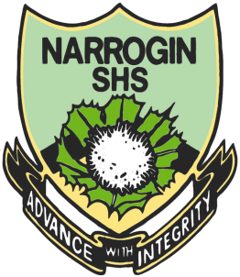
Name: __ Teacher:

Yr 8 Aboriginal Language & Culture Studies

Total marks  /46 | % | Weight  20%

Task One

Traditional Aboriginal Music & Musical Instruments

Due____________

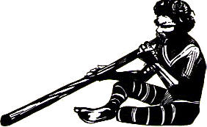

- Use your own knowledge and the Internet to do a draft Brainstorm about Traditional Aboriginal music and musical Instruments. A3 Paper (draft)
(10 marks)

- Draw examples of 3 or more instruments around the edges of your brainstorm. (6 marks)

- Once you have completed your Brainstorm bring it to your teacher (Miss Rintoul – Wednesday Week 7) and get it checked. You will then be given another piece of A3 paper to do your good copy on.

This good copy should be neat, colourful and informative. It should be suitable for display purposes, as it will be glued onto a sheet of cardboard.
(20 marks)

- Construct an Wordle using words you have researched about Traditional Aboriginal Music.
This Wordle must contain at least 20 words and they must be spelt correctly.
(10 marks)

What is a Wordle

A wordle is a visual depiction of the words contained in a piece of text or from a particular topic. Generated by a web-based tool of the same name, a wordle is created by manipulating the words and arranging them into a kind of graphic.

Below are 2 examples.

